Tetrahymena Experiment Manual

John Giannini & Michele Severson

St. Olaf College, 2015

1500 St. Olaf Ave, Northfield MN 55057

[giannini@stolaf.edu](mailto:giannini@stolaf.edu)

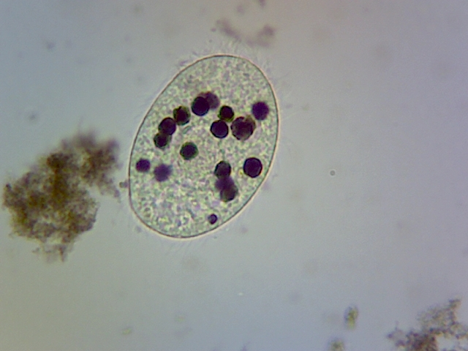

Tetrahymena Resource Manual

The concept behind this manual is to demonstrate experiments with Tetrahymena and Paramecium that can provide a starting point for student generated projects. The methods and experiments have purposely been kept straightforward so that students can spend their time asking questions and not trouble-shooting the methods.

The format of the manual is to first introduce you to the particular experiment and then provide some ideas for added projects the students could perform. The manual contains all the pertinent information to make the projects a success. You should perform the methods ahead of time to fine-tune them for your own situation.

The methods in this manual are not new (see reference section) but have been modified and/or compiled for easier use. My hope is that you come up with your own ideas of how to use these methods.

Methods

1. Counting Tetrahymena
2. How to grow Tetrahymena (metabolism, cell growth, cell division)
3. Measuring phagocytosis with Tetrahymena (phagocytosis, exocytosis, cytoskeleton)
4. Acid phosphate assay (exocytosis, enzymology)
5. Contractile vacuole closing with Paramecium and Tetrahymea (homeostasis, water relations)
6. Motility with Tetrahymena (ciliary movement, cytoskeleton)
7. Chemotaxis with Tetrahymena (cell response to stimuli, cell signaling)
8. Tetrahymena deciliation (protein synthesis, metabolism)
9. Galvanotactic response by Tetrahymena (electrophysiology, cell signaling)
10. Aerotaxis with Tetrahymena (cell signaling)
11. Tetrahymena speed/tumbling (cell movement, cytoskeleton, cell signaling)

**1. How to count Tetrahymena**

1. The easiest way to count Tetrahymena is to place 30 μL of culture on a microscope slide. Add 5 μL of 5% gluteraldehyde to 30 μL on the slide. Cover with a cover slip. Count 10-20 fields of view at 400x total magnification. This method is qualitative.
2. The next method for counting Tetrahymena is using a hemocytometer (we used 1/10 mm deep/Spencer Bright Line hemocytometer).
3. Add 190 μL of Tetrahymena to a microcentrifuge tube. Next add 10 μL of 5% gluteraldehyde (in H2O) to the tube and mix.
4. 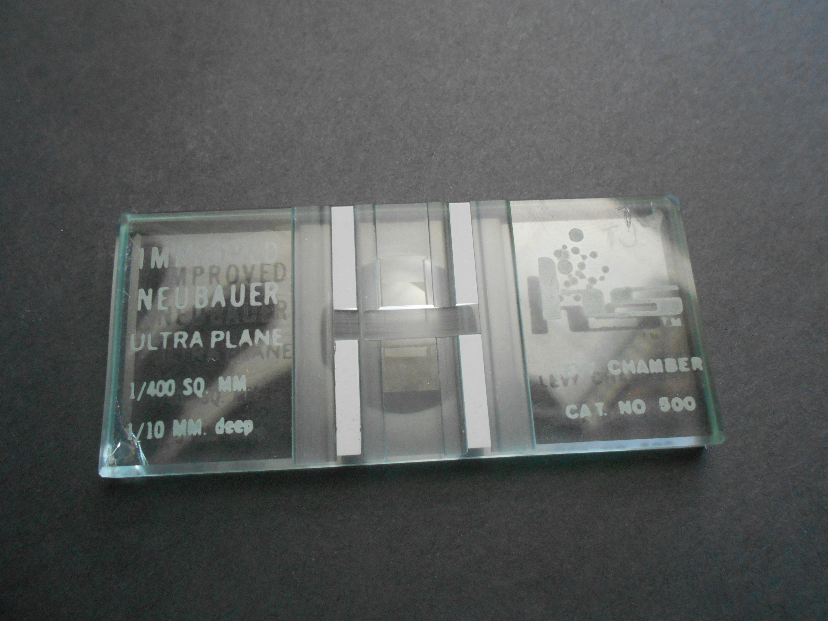Place a small drop from the tube onto the silvered surface of the hemocytometer then place the extra thick cover slip over the mirrored surface.
5. View at 40x total magnification.
6. Count at least 100 cells (count cells in an area that add up to ≥ 100 cells). Keep track of the area in mm2 (1 mm2 = 0.1 μL volume on grid).
7. Multiple by 20/19 to your cell count for the actual number of cells per given volume.
8. See appendix for picture of hemocytometer grid.
9. Another qualitative way to measure Tetrahymena is to use a spectrophotometer.
   1. Set the spectrophotomenter at 540 μm (light scattering)
   2. Zero the spec. with growth media in a cuvette
   3. Place a cuvette with tetrahymena in the spec and take your readings

You can make this method quantitative by making a standard curve of # of cells per OD using the hemocytometer.

**2. How to grow Tetrahymena**

1. Tetrahymena are readily available from the following sources:
   * Carolina Biological
   * American Type Culture Collection (<http://www.ATCC.org>)
   * TETRAHYMENA STOCK CENTER (tetrahymena.vet.cornell.edu)
2. Tetrahymena can be stored for 4-6 weeks in a capped culture tube in a 1% Protease Peptone media (autoclave tubes with 5 ml PP). Simple inoculate the tubes with 200 μL of your stock and leave at room temp. If you have an incubator, 15° C is best.
3. 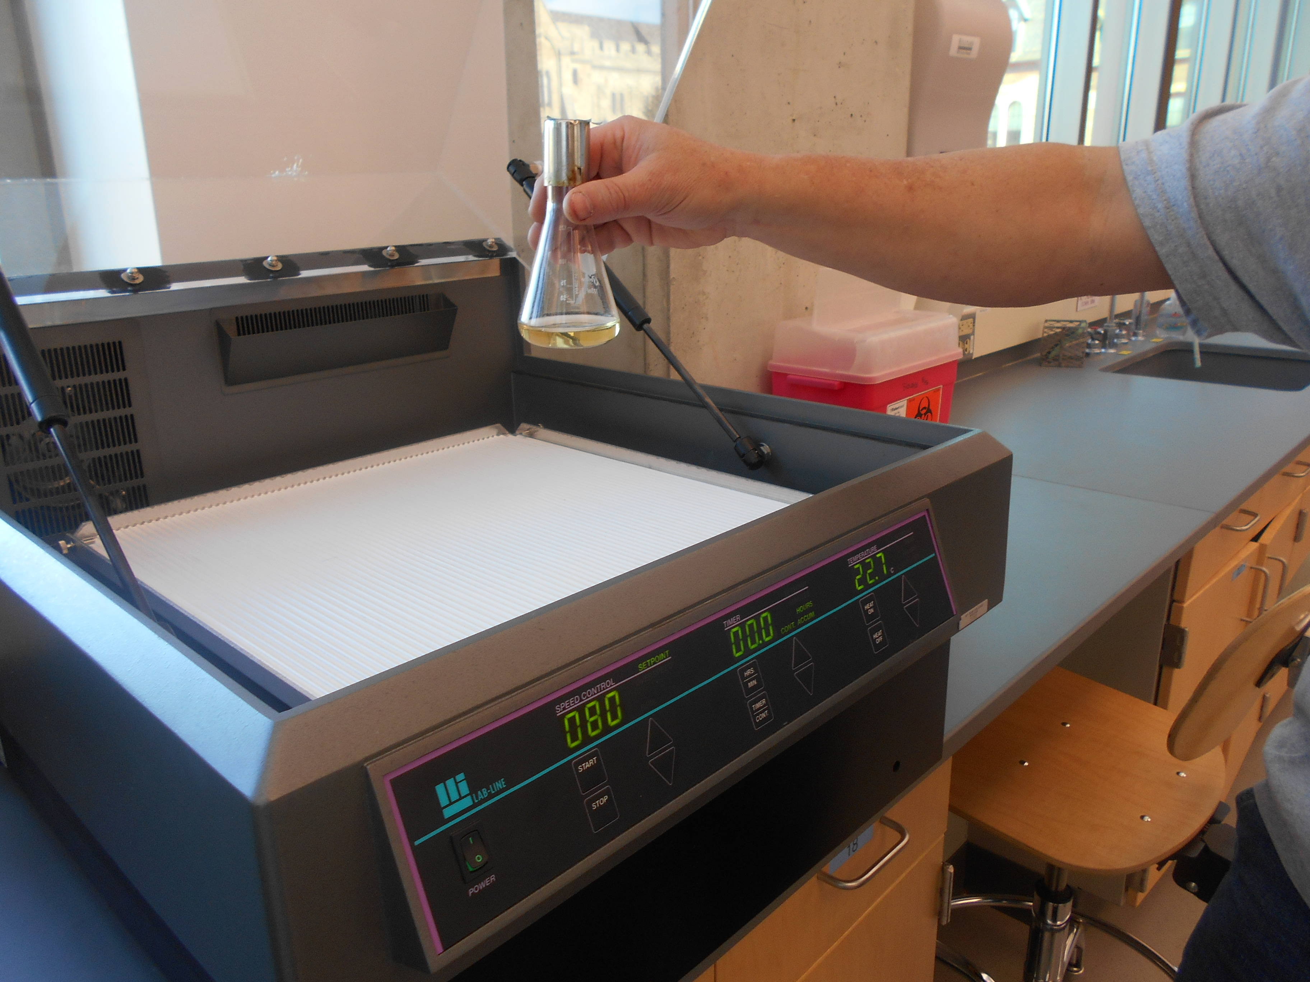A culture of tetrahymena can be grown by inoculating 25 ml of MODIFIED NEFF MEDIA. Add 500 μL of your stock culture to a culture flask or a clean Erlenmeyer flask with 25 ml of sterilized media. Cover with a foil top. It will grow best at 31° C with gentle swirling, but it can be grown at room temp (will be in log growth phase in about 4 hours). Cultures are best used after 24 hours of growth.

Modified Neff Media

0.25% Protease Petone 2.5g/L

0.25% Yeast extract 2.5g/L

0.5% glucose 5g/L

33.3 μM FeCl2 33.3 ml of 10 mM FeCl2 per liter

Be sure to use clean glassware with NO soap residue. Cleaning with alconox works well.

Media has a shelf life of about 2 months.

**3. Growth experiments with Tetrahymena**

1. Grow a culture of Tetrahymena and measure cell growth over a 50-hour period. (See appendix for growth curve example).
2. Vary the temperature for culture growth. Find the maximum temperature for growth.
3. Grow a culture using dilutions of the media.
4. Replace glucose with other sugars in the growth media.
5. You can do growth curves with various environmental pollutants in the growth media.
   1. Ethanol
   2. Herbicides
   3. Pesticides
   4. Excess salt
   5. Concentrations of these will have to be experimentally determined (check the literature)
6. You could use a defined media and vary selected components (see defined media in the appendix)
7. You could vary the pH of the growth media. Adjust the pH of the growth media with 0.5 M KOH or 0.5 HCl
8. Vary the effect of more less shaking of the sample

Measuring Phagocytosis with Tetrahymena in 1% India ink

The use of Tetrahymena for measuring phagocytosis has been used by many labs to study the digestion of food by Tetrahymena or simply to measure their health. The method is simple and very easy to use in a teaching lab.

Materials

* Log phase of Tetrahymena culture (must be fresh—24-48 hour culture)
* 1% India ink (HUNT- SPEEDBALL) (carbon particles 0.013-0.77 μm)
* 1.5 ml microfuge tubes
* 5% gluteraldehyde
* microscope slides and cover slips
* pipettes (1000 μl, 200 μl, 20 μl)
* stop watch

Procedure

1. Place 500 μl of Tetrahymena culture in a microfuge tube.
2. Start uptake with the addition of 500 μl 1% India ink (well mixed), mix ink and Tetrahymena carefully and let sit at room temp (do not hold in your hand).
3. At 2, 5, 10, 20, and 30 minutes, take a 30 μl sample of Tetrahymena and ink and place it on a microscope slide. Quickly add 5 μl of a 5% gluteraldehyde solution to the 30 μl sample and mix with the edge of a cover slip. Place the cover slip on top.
4. Count the number of vacuoles at 400x magnification in 10-20 fields of view (more is better). Be careful to only count cells that have at least 1 ink vacuole (there are some cells that are not actively undergoing phagocytosis). Also, the cells are 3D, so focus through the cells when you count.



Phagocytosis with Tetrahymena

1. You can vary the India ink concentrations used for uptake (0.5%, 1%, 2%, 3%).
2. You can measure uptake at various temperatures between 0-40° C.
3. You can measure carmine red (50 mg/ml in H2O) uptake. Carmine should be made up fresh and shaken well before use. The particles are larger than India ink. Do the phagocytosis experiment by replacing 500 μl of ink with 500 μl of Carmine red.
4. You can purchase polystyrene beads of defined sizes and measure uptake. The beads are expensive and come in dyed and undyed form (0.2 μm-3.0 μm sizes). They typically come suspended in H2O. You don’t need many to watch uptake. Experiment with a few μl per 500 μl Tetrahymena assay or you could dilute the beads to 0.5% solids and add 500 μl. See sheet on poly beads in the appendix.
5. You can measure uptake of ink over a long time period (1 hour- 1.5 hours).
6. Paramecium will not take up India ink but will take um carmine red. You can buy an active Paramecium culture from Carolina Biological. They last quite a long time. Carefully take 500 μl of sample from the bottom of the culture (the muck at the bottom is loaded with Paramecium) and do uptake with carmine red.
7. You can replace ink with 500 μl of a dilute yeast culture. Be careful to dilute the yeast culture so you can see the Tetrahymena. Add a small amount of dry bakers yeast to some warm water. It helps to add a little sucrose to the culture. When the culture starts to give off CO2, it is ready. Dilute the culture with H2O. Yeast are 3-4 μm in diameter. They are also a natural food source for Tetrahymena.
8. You can compare the size variation in vacuoles with ink, carmine red, and yeast.
9. 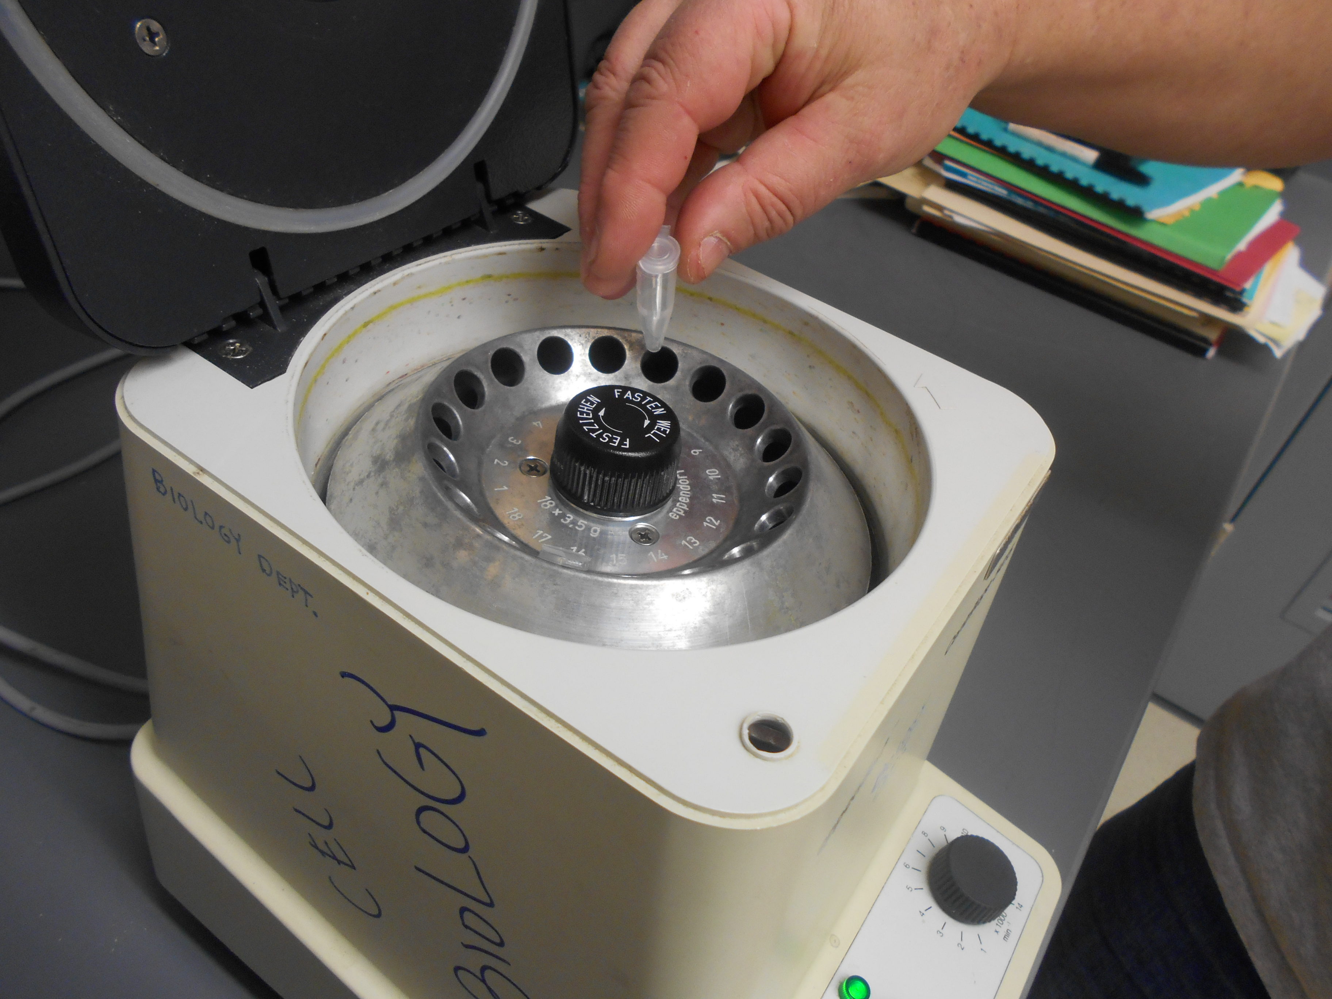You can do a pulse chase experiment. Start your experiment with ink; after a few minutes of uptake, spin the cells in a mircofuge at 14,000 rpm for 20 seconds.

Replace supernatant with 500 μl fresh media and suspend pellet gently. Repeat. Now follow the ink vacuoles over time. Keep track of how they travel through the cell.

1. You can allow the cells to accumulate a maximum number of vacuoles then chase them (as in idea 9) and watch the rate of exocytosis. Count the vacuoles as you normally do, and you should see a decrease in the average # of vacuoles over time.
2. You can do a pulse-chase-pulse experiment. Set up your experiment as in idea 9, but rather than using media for the final suspension, use 500 μl of a carmine solution (50 mg/ml of H2O). Watch what happens to the black ink vacuoles. Is there a linear of non-linear processing?
3. You can use ink and carmine in the same experiment and look for a preference. Rather than add 500 μl of ink, add 250 μl of ink and 250 μl of carmine red. Count the number and color of vacuoles over time. You can do this with yeast as well as polystyrene beads.
4. You can compare uptake in a fresh log phase culture to one that is past log phase (stationary phase). See the chart of growth of Tetrahymena in the growth section for times.
5. 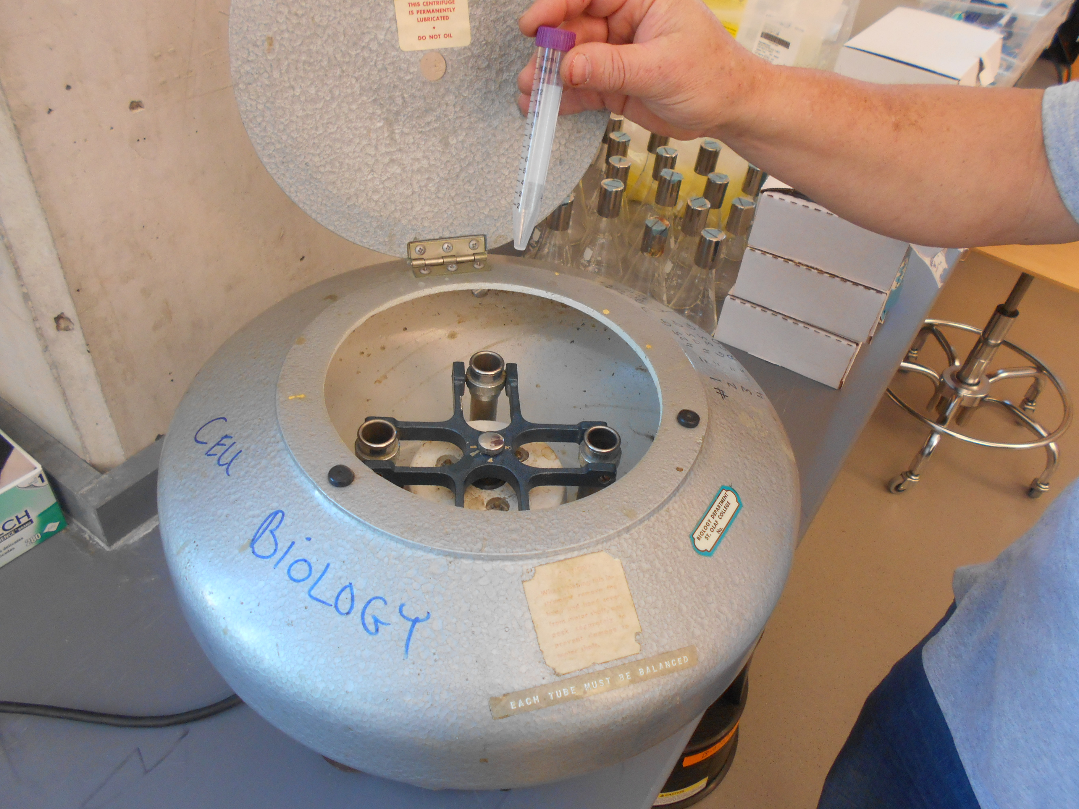You can compare uptake in a log phase culture to a starved culture. To make a starved culture, you need to grow a 25 ml log phase culture. Spin the cells down in a table top clinical centrifuge (4 setting, 1 minute), then suspend cells carefully in starvation media (10 mM TRIS pH 7.4). Let the cells sit overnight before you use them.
6. You can use a starved culture for many of the other ideas in this manual.
7. You can use dyed yeast to view pH chance in the vacuoles. This experiment only works using Paramecium.

Dyed Yeast

* Grow a yeast culture
* Add bromocresol green dye to the culture until it turns green. (See appendix for bromocresol green colors at different pHs).
* Swirl; let it sit for 30 minutes.
* Boil yeast for 5 minutes.
* Centrifuge yeast and wash with H2O until no dye is in the supernatant.
* Suspend yeast in H2O.

Take a 500 μl sample of Paramecium, add a couple of drops to yeast solution (more or less depending on how concentrated the yeast are). View cells over timer using protoslow. If you kill them, you lose the resolutionof the colors. Keep track of the movement and the color of the vacuoles. You can do this with Tetrahymena, but there is less color (pH) variation.

An alternate way to trap Paramecium and Tetrahymena is to paint nail polish in a strip on a microscope slide. For Tetrahymena, use a very thin layer of polish. For Paramecium, the layer can be a little thicker. Place 10 μl of sample next to the strip. Place a cover slide over the top. Some cells will be trapped and easily observable.

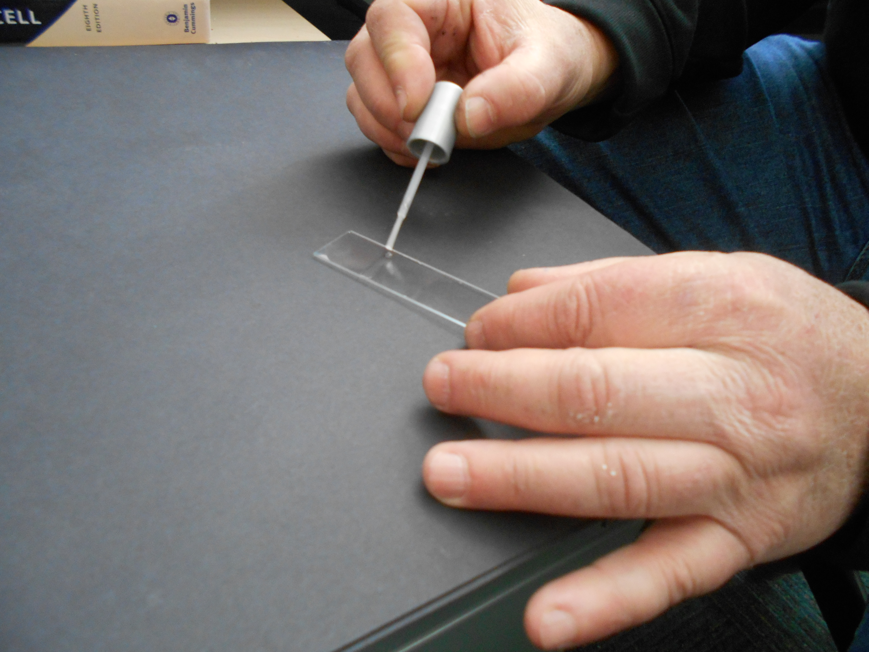

1. You can stain Tetrahymena and Paramecium cells with 0.1% neutral red (in H2O). Acidic vacuoles will be in red. This is a good, quick experiment to demonstrate that vacuoles become acidic during phagocytosis.
2. You can measure uptake of ink at different pHs. Make up growth media and set the pH with a 0.1 M HCl or 0.1 M KOH. Make up a number of different pHs (6.0, 6.5, 7.0, 7.5). Take 500 μl of a log phase culture and pellet the cells (14,000 rpm for 20 seconds in a table top microfuge). Re-suspend pellets in 500 μl of a growth media at various pHs. Add ink and count cells. You may want to wait 15-10 minutes before you add the ink to let the cells adjust to the new pH.
3. You can measure uptake in various osmotically adjusted solutions. Osmoticums that should work well are sucrose and mannitol. Mix up 1M stock solutions of your osmoticum. Add various amounts to 500 μl of log phase tetrahymena culture. Wait 5 minutes and then add ink. If you have an osmometer, you can measure the osmolarity of the solution. Be sure to control for volume.
4. You can measure uptake at various salt concentrations. Mix up 1M stock solutions of your salt of choice. Add various amounts to your 500 μl log phase Tetrahymena culture. Proceed as described above (in #19).
5. You can measure the effect of cytoskeleton inhibitors on phagocytosis.

Stock Solutions

Colchicine (tubulin) 25 mM (10 mg/ml in H2O)

Nocodazole (tubulin) 2 mg/ml (7mM) in DMSO

Cytochalsin B (actin) 14mM (6.7 mg/ml) in DMSO

Begin by using 1/100 dilution of the inhibitor with Tetrahymena. Look for a dosage effect.

* Make sure you control for the solvent used
* Incubate for 5-10 mintues before you start the phagocytosis assay

1. You can measure uptake in the presence of various environmental pollutants. Look for a dosage response.

* Insectiside
* Herbicide
* Organic (ETOH, methanol, acetone, etc.)
* Fertilizers

Be sure to incubate for 5-10 minutes before you start phagocytosis assay.

1. You can measure the effect of phosphorylation inhibitors.
   1. PAO (phenylarsine oxide) 300 mM (50 mg/ml in DMSO) will inhibit tyrosine phosphatase.
   2. Cantharidine (127 mM, 24 mg/ml in acetone) will inhibit protein phosphatase 2A
2. You can measure the effect of a calcium/cadmodulin inhibiter on phagocytosis.
   1. Trifluoperazine (3.0 mM in DMSO)
      1. Use 1/100 dilution to start
      2. There are a number of others you can try, such as CPZ, W5, and A23187 (a calcium ionophere)
3. You could measure the uptake of ink by the Tetrahymena in the presence of other protozoa.
4. You can look at uptake of ink by other protozoa. Obtain cultures from a biological supply house such as Carolina Biological. Use a drop of 1% ink and a drop of the culture. Determine if they take up the ink. You can expand this to an uptake assay similar to tetrahymena.

**4. Measuring the rate of contractile vacuole closing with Paramecium and Tetrahymena**

The contractile is an organelle that is used to remove excess water from protozoa due to osmosis. It is easily visualized and the pumping can be quantified. As with phagocytosis, many experiments can be designed using this simple technique.

Paramecium

Materials:

* Nail polish
* Culture of Paramecium (Carolina Biological)- these cultures last up to 6 weeks if properly treated (Aerate).
* 20 μl pipette
* Microscopy slides
* Cover slips
* Stop watch

1. Take a microscope slide and carefully paint a thin strip of nail polish.

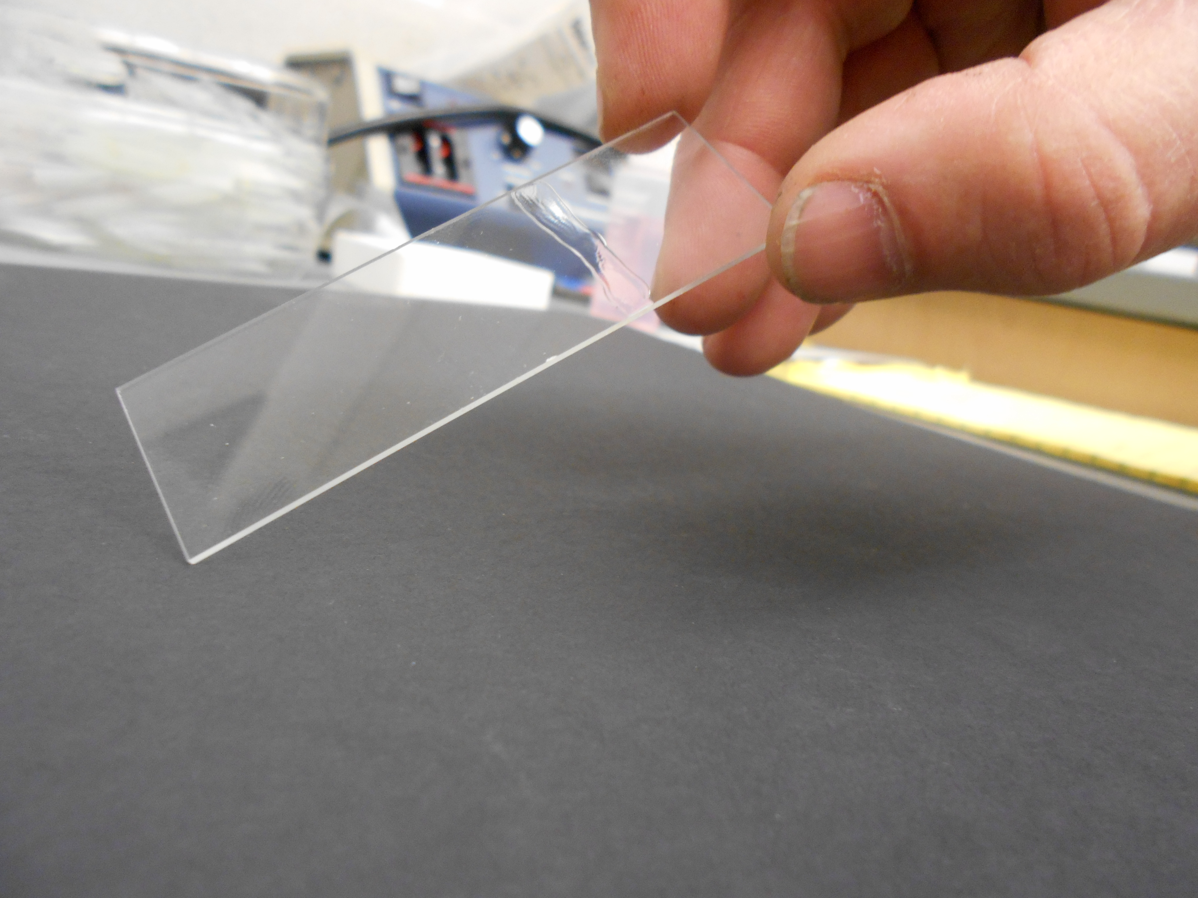

Be careful to wipe the brush on the edge of the bottle to remove most of the polish.

1. Let your slide dry for about 15 minutes.
2. Place a 10 μl sample of Paramecium next to the strip of dry polish then cover with a cover slip.
3. Now (under 40x magnification), find the Paramecium whose mobility is reduced. Next, increase your magnification to 100x. It is important to use low light conditions, as heat will kill them.
4. Pick one of the two contractile vacuoles and count how long it takes for 5 contraction events. Record your data.
5. Move your slide and repeat 5-10 times.

Tips for Paramecium

1. It is useful to collect about 500 μl of Paramecium culture in a 1.5 ml microfuge tube. You can then allocate what you need for an experiment.
2. Always collect from the bottom of the container.
3. If you look carefully, you can see them in the microfuge tube. Check to make sure you have collected a good number.

Tetrahymena

You can use the same process for Tetrahymena as you did for Paramecium. The only difference is that you need to make the polish strip as thin as possible (slides with polish can be reused). You also need to count them at 400x magnification.

Be aware that Tetrahymena only have one contractile vacuole.

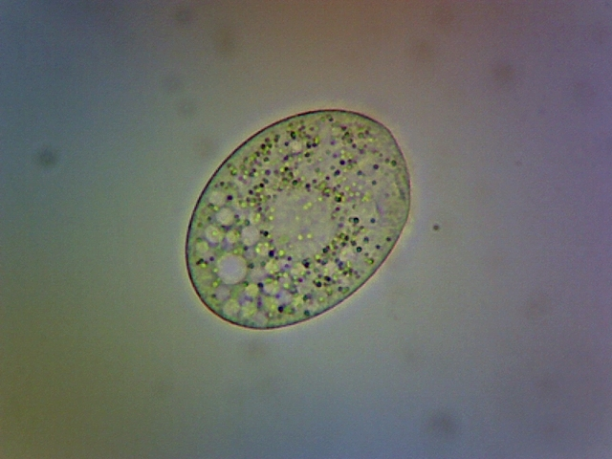

Experiments with Contractile Vacuoles

* + - 1. You can add 50μl of Paramecium or Tetrahymena and 50μl of known concentrations of mannitol (0mM, 50 mM, 100 mM, 200 mM, 600 mM). Mix together. Wait 5 minutes and determine the rate of pumping. This experiment can be done with various types of solutes (salt, sugar).
      2. You could measure the rate of the two vacuoles in Paramecium. Are the rates the same for both vacuoles?
      3. You could measure the effect of pH on the rate of the vacuoles. See methods under the phagocytosis section (see page 9)
      4. You could compare rates for Paramecium and Tetrahymena. Obtain 500μl of each and spin in a microfuge tube (10,000 rpm for 4 seconds). Re-suspend in known concentration of osmoticum and count.
      5. The effect of cytoskeleton inhibitors on the rate of pumping could be measured (see page 9)
      6. Measure the effect of environmental pollutants (pesticide, organic, salts, etc.) on the rate of pumping

**5. Measuring Motility (Movement) with Tetrahymena**

Tetrahymena are constantly on the move. They sense their environment and move toward food and O2 and move away from various other substances. This assay gives a simple method to determine changes in Tetrahymena motility due to various treatments and experimental conditions.

Materials

* Tetrahymena culture in log phase
* Dissecting microscope
* 10μl capillary tubes (Drummond microcaps)
* Black, thin line Sharpie
* Loctite Fun-Tak mounting putty
* Microscope

1. 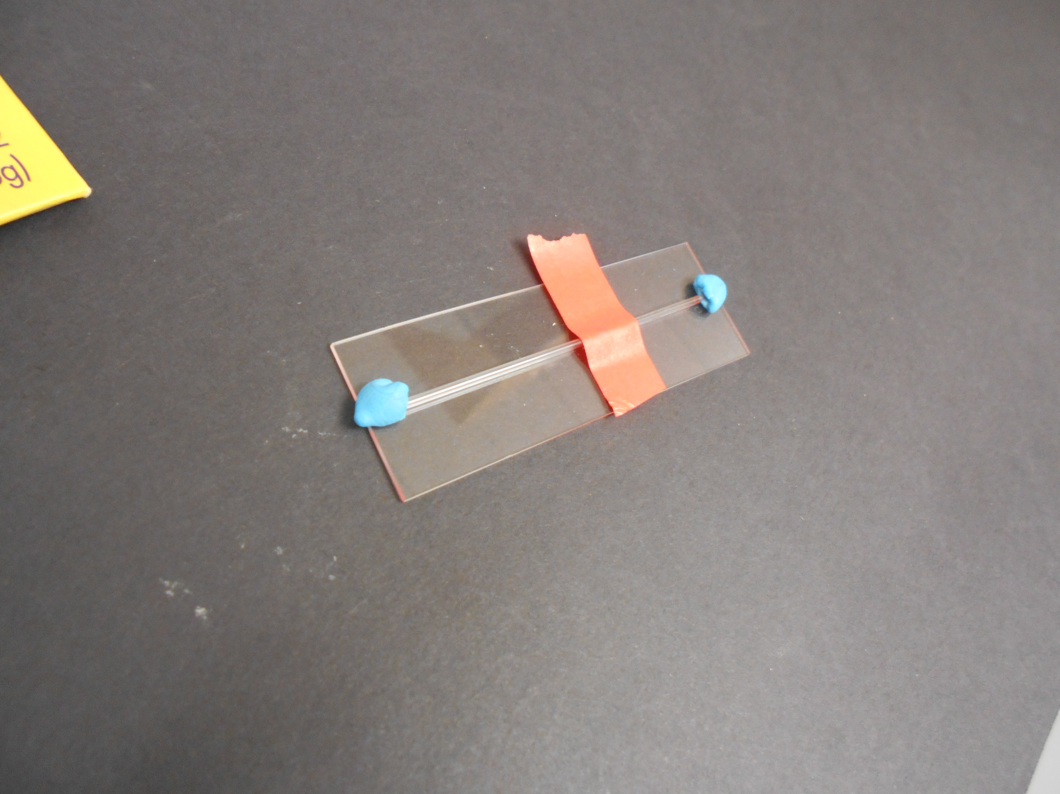Fill a 10 μl capillary tube with Tetrahymena form a fresh culture. Remove all bubbles.
2. Plug both ends with a ball of Fun-Tak.
3. Place on a microscope slide
4. Draw a thin line in the middle of the capillary tube or place a piece of colored electrical tape over half of the capillary tube.
5. Count how many Tetrahymena cross the line in 2 minutes.
6. If the Tetrahymena are too numerous to count, dilute some of your culture with growth media until you can count their movement.
7. If the Tetrahymena culture is too dilute, you can concentrate them by spinning them in a microfuge tube at 14,000 rpm for 20 seconds. You can then add media to the pellet and suspend.

Experiments with Tetrahymena Movement

1. You can add cytoskeleton inhibitors. See concentrations and molecules to use in the phagocytosis section (see page 9)
2. Vary the pH of the media. See directions in the phagocytosis section.
3. Compare movement in starvation media versus normal media.
4. Search the literature for attractants and repellents. Try them in an assay.
5. Try various environmental pollutants.

* Herbicides
* Pesticides
* Organics
* Fertlizers

1. Try Ca2+ channel inhibitors
2. You can also try K+ channels inhibitors.

**6. Chemotaxis Measurements with Tetrahymena**

Tetrahymena will move toward some chemical signals and away from others. You can build a simple apparatus to observe and study this phenomenon.

Materials

* Log phase tetrahymena culture
* microscope slides and cover slips
* capillary tubes (Drummond microcaps 10μl or larger)
* straw
* Loctite Fun-Tak mounting putty

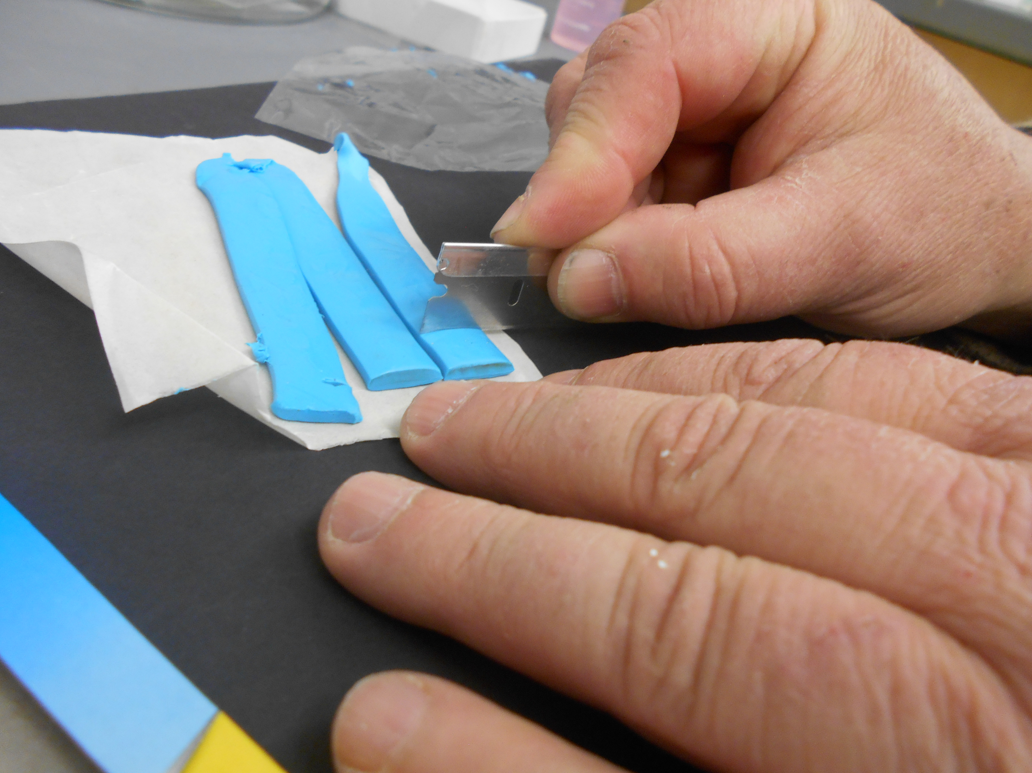

Procedure

1. Cut putty strips in squares

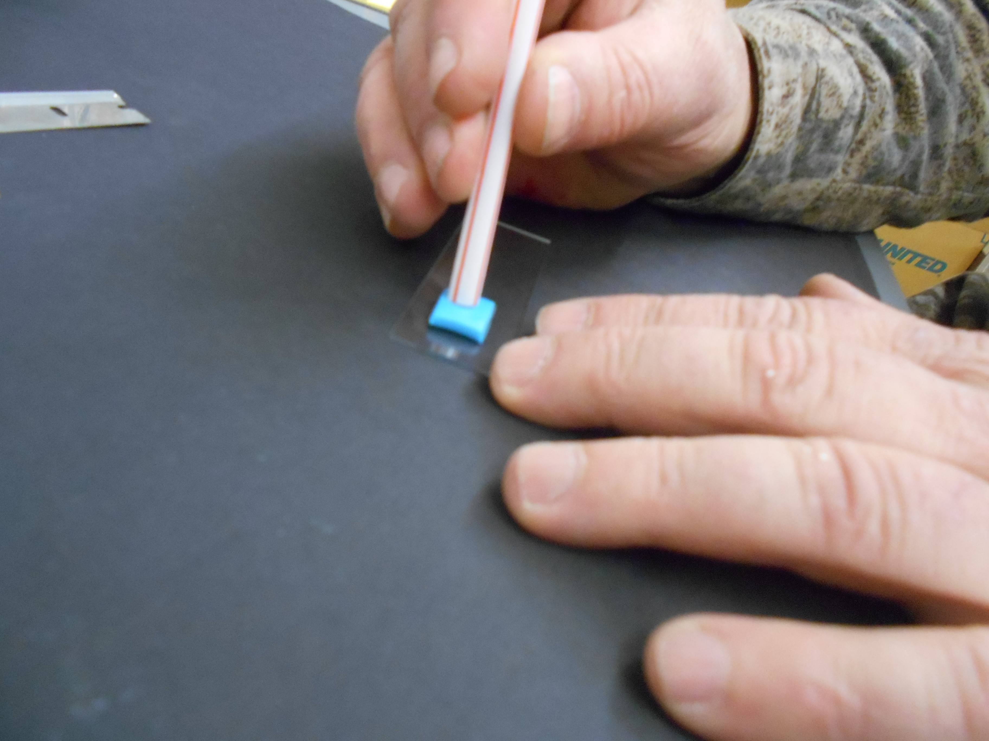

1. Punch hole in putty square with a straw
2. Press square with hole in it onto a microscope slide

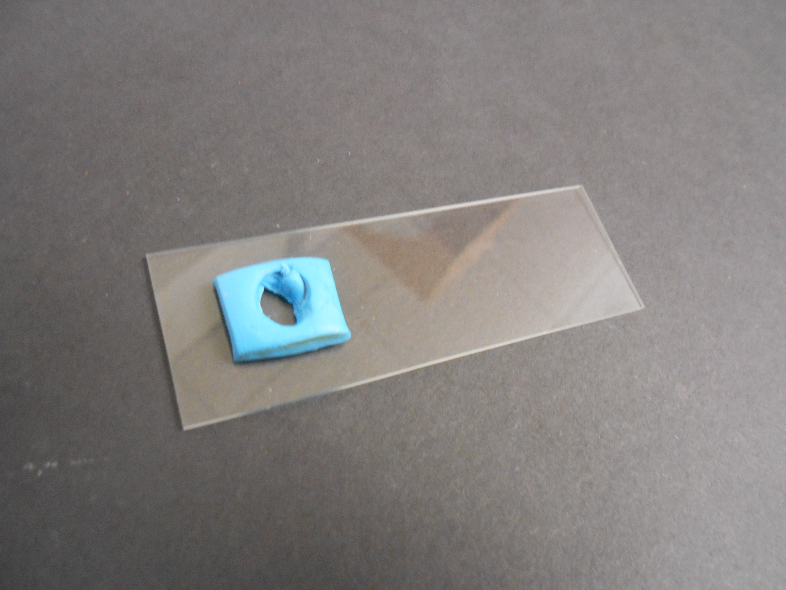

1. Fill a capillary with a test solution (attractant or repellent) and plug one end with a ball of Fun-Tak (make sure there are no air bubbles)
2. Press end of capillary into clay

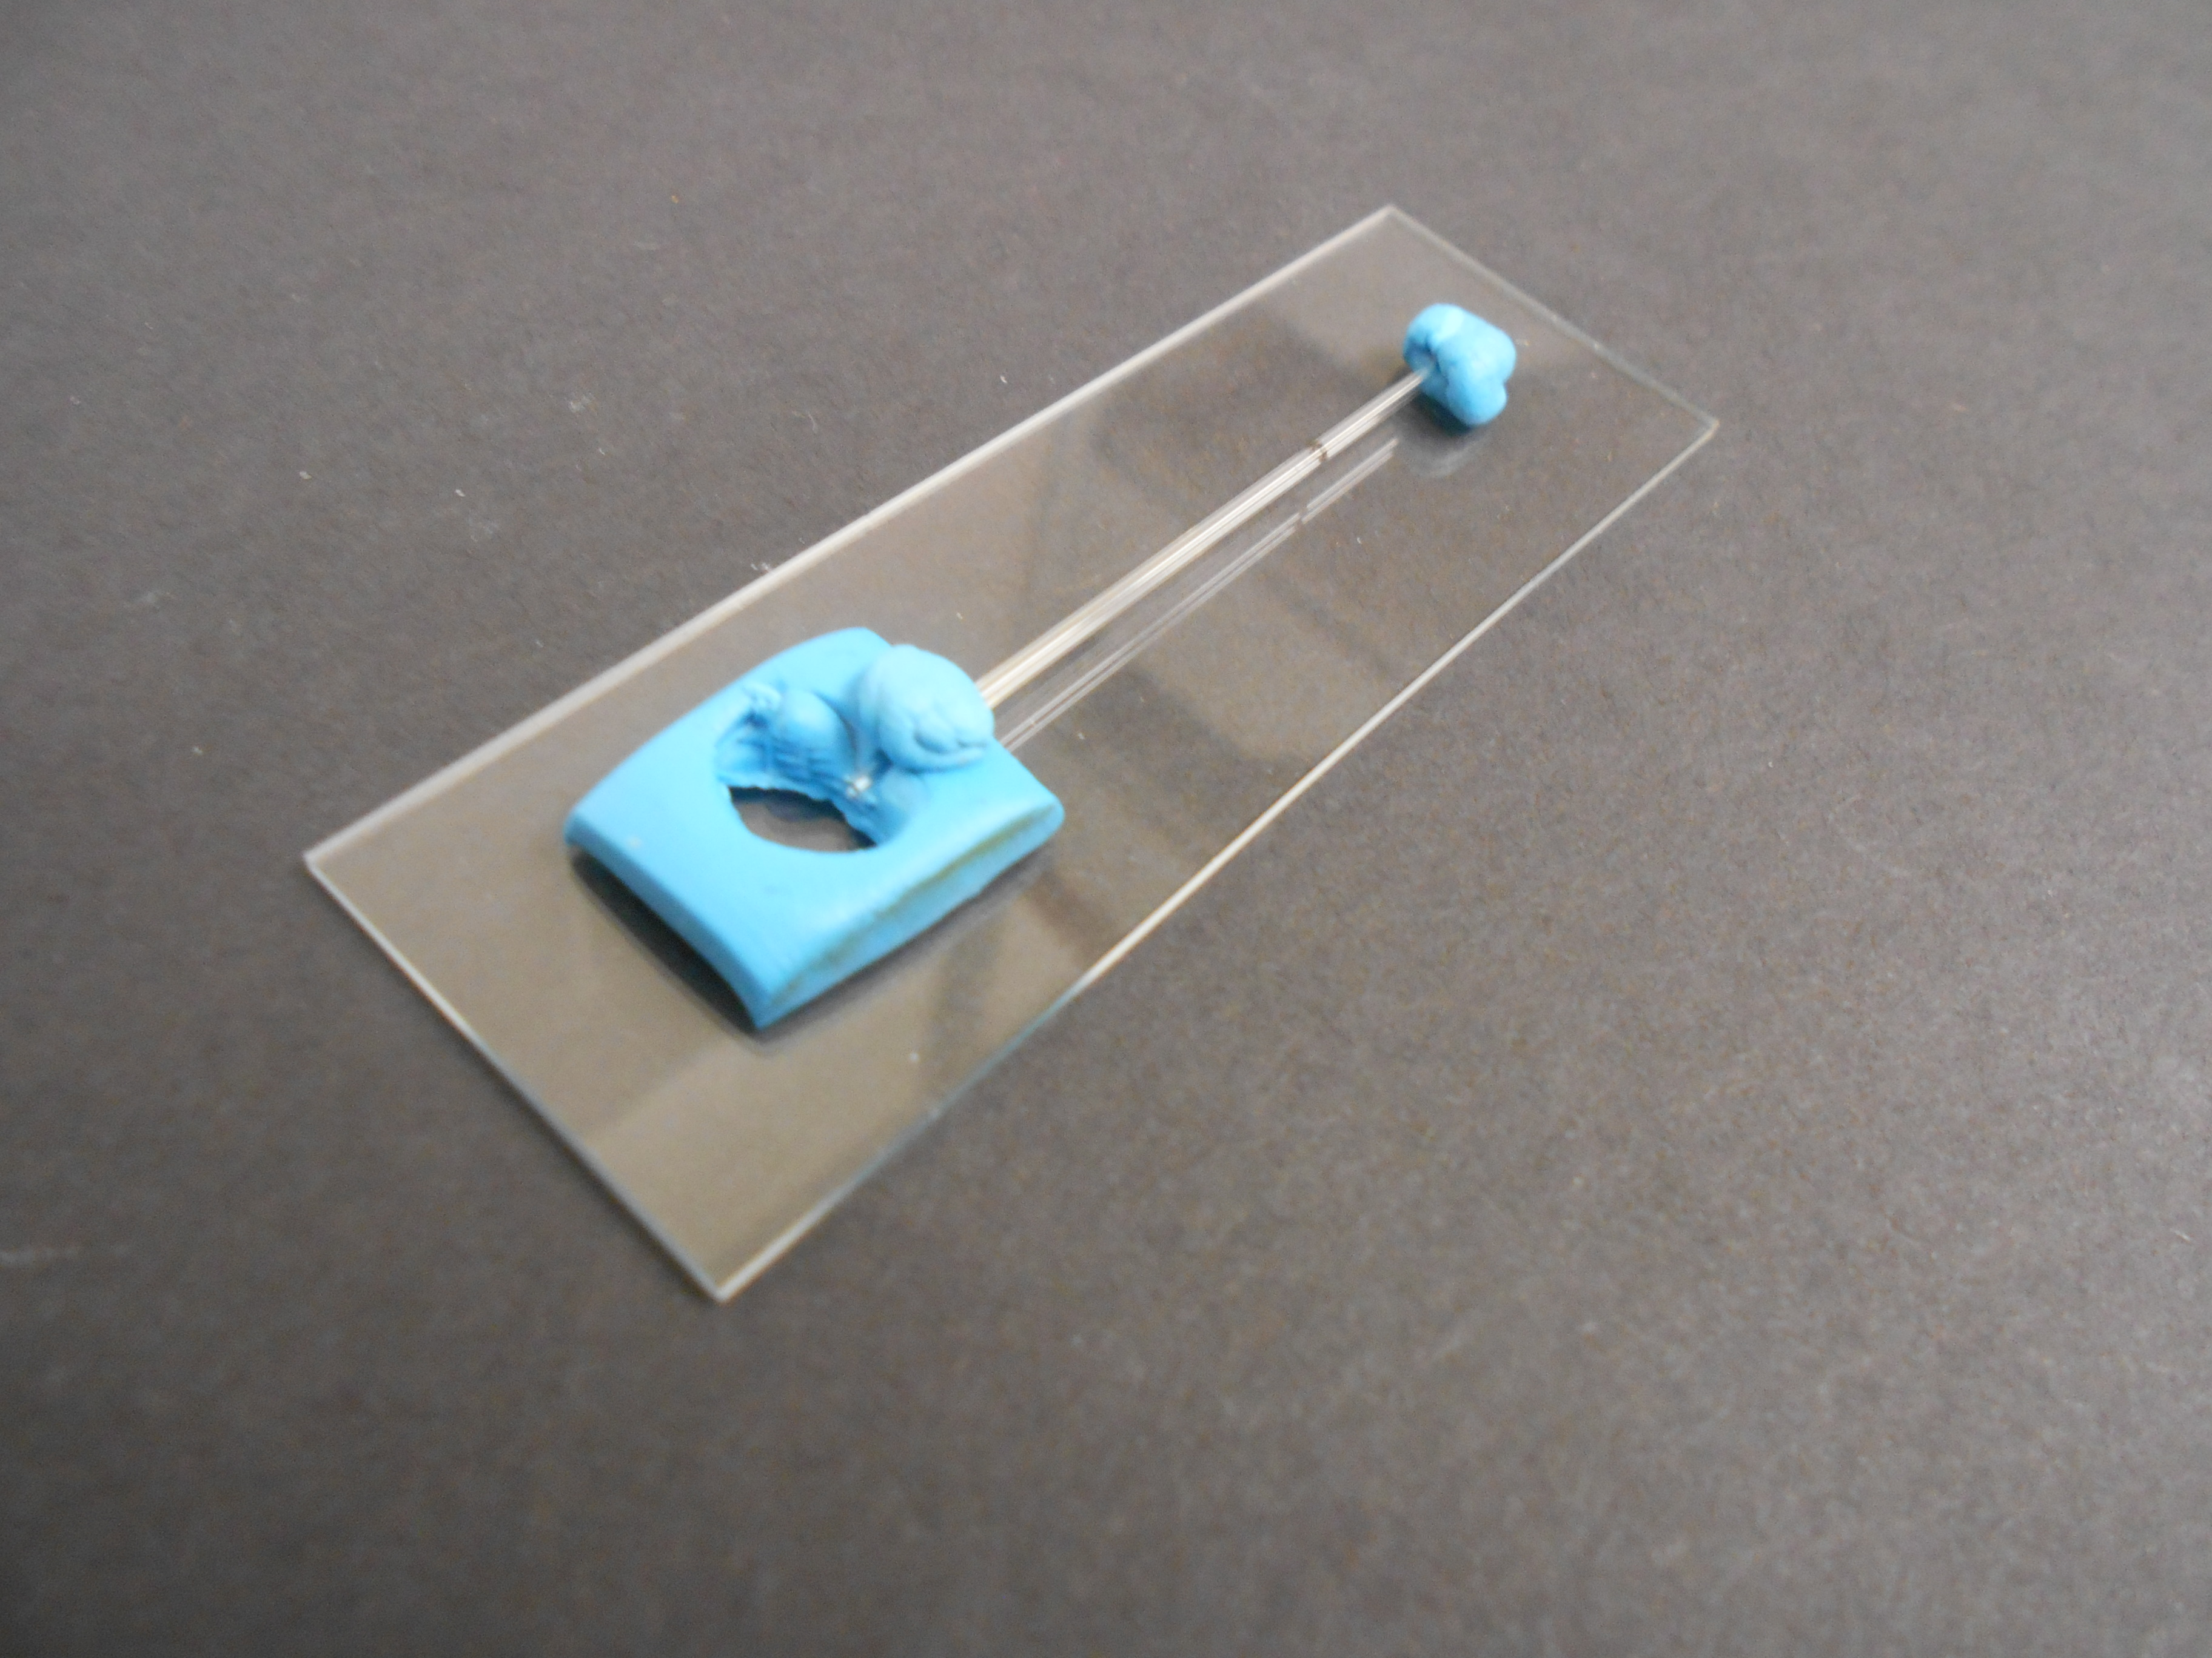

1. Fill hole with Tetrahymena culture so that it covers the end of the capillary tube. The Tetrahymena should be pelleted and re-suspended in the test solution minus the attractant or repellant. (fill a microfuge (1.5 ml) with Tetrahymena culture and spin at 14,000 for 20 seconds, re-suspend pellet in 1 ml of solution)

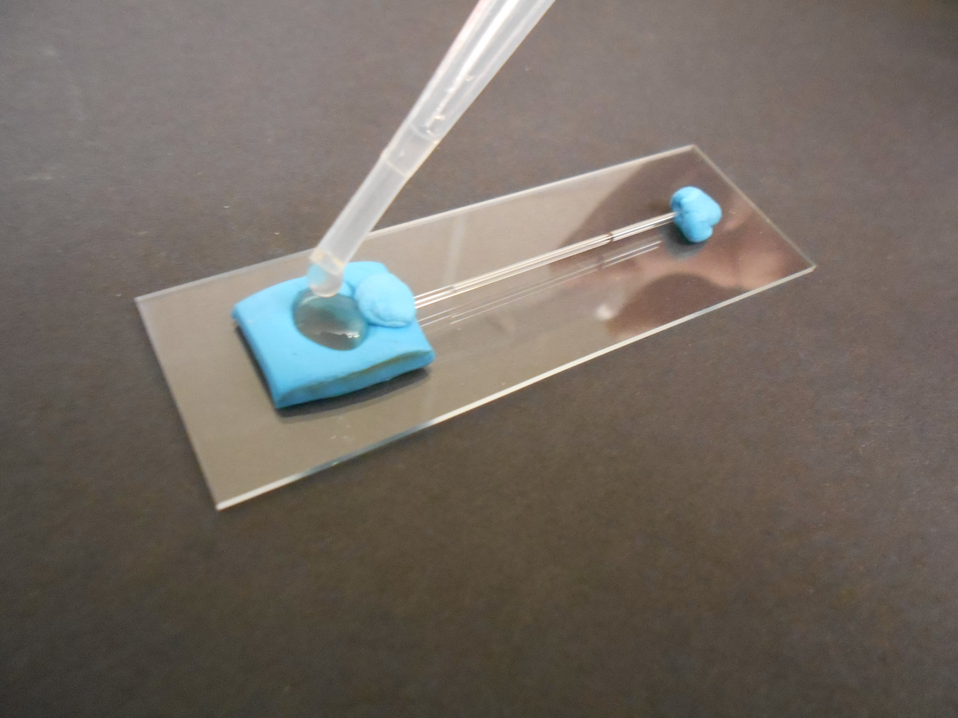

1. After 30 minutes count the number of cells in the capillary (see counting Tetrahymena). If a larger capillary tube is used, use 1μl of 5% gluteraldehyde per 10μl of sample.

Chemotaxis experiments with Tetrahymena

1. You could compare chemotaxis of cells for their growth media vs. H2O.
2. You could compare starved cells to non-starved cells for chemostaxis to various substances (sugars, amino acids, etc.)
3. You could try and find out what components in the growth media cause chemotaxis (see growth media recipe)
4. Look in the literature for chemotaxtic substances. Try them with, starved and non-starved cells. There are lots of cool studies in the literature.
5. Look for molecules that may interfere with chemotaxis (organic molecules, cytoskeleton inhibitors, pollutants, herbicides etc.)
6. See in chemotaxis is pH dependent.
7. See if chemotaxis is temperature dependent.
8. Try Ca2+ channel inhibitors and/or K+ channel inhibitors.

**7.Tetrahymena Deciliation**

By treating a culture of Tetrahymena with dibucaine you can cause the cells to lose their cilia. The Tetrahymena will re-grow cilia after about 80 minutes. Deciliation provides a great experimental system for asking questions about cilia re-growth.

Materials

* Clinical centrifuge
* 15 ml plastic centrifuge tubes/blue cap polypropolene
* Log culture of Tetrahymena (25 ml)
* Extra media (about 50 ml)
* Microscope/slides/cover slips
* Timer

1. Add 12 ml of your culture to a 15 ml centrifuge tube.
2. Spin in a clinical centrifuge at a setting of 4 for 1 minutes
3. Pour off super natent and suspend pellet in 5ml of cultural media with 5 mg dibucaine added. Make fresh. Let sit for 30 seconds to 2 minutes with light mixing. You may need to vary the time of the incubation to optimize your results.
4. Add 10 ml of media to the dibucaine treated cells. Mix and pellet at a setting of 4 for 1 minute
5. Suspend pellet in fresh media (15 ml) and pellet again.
6. Suspend pellet in 15 ml of media and place in an incubator at 31oC with gentle shaking movement.
7. Movement measurements at 10-minute intervals. Count 30 random cells. Indicate how many are moving. You must decide what you define as movement and be consistent in your measurements.

Experiments with Deciliation

1. Measure the effect of temperature on cilia regrowth.
2. Measure the effect of regrowth on starved versus unstarved cells.
3. Use different types of media and look at the effects of regrowth.
   1. Sugar
   2. Amino acids
   3. salts
4. Look at the effects of cyclohexamide on regrowth. Cyclohexamide is a protein synthesis inhibitor (final cenc. 10μg/ml)
5. Measure the effect of cholchicine (0-4mg/ml) on regrowth. Cholchicine inhibits microtubule polymerization.
6. Try the experiment out on Paramecium.
7. Measure the effect of other cytoskeleton inhibitors and calcium/calmodulin inhibitors.
8. Measure the effect of Actinomycin D (a transcription inhibitor) on cilia regeneration (100-200μm final cenc.)

**8. Galvanotactic Response by Tetrahymena and Paramecium**

When placed in a capillary tube with a voltage applied across the tube, Tetrahymena will move toward the negative electrode. This response is due to the interaction of the electrical current and calcium and potassium channels in their membranes. The response is dramatic and easily observed.

A simple explanation for the response is that when a voltage is applied to Paramecium or Tetrahymena, the end facing the anode is hyperpolarized which causes K+ channels to open and the cilia to beat faster. On the side of the protozoan facing the cathode, depolarization takes place, causing Ca2+ channels to open and the cilia to beat in reverse. This combined effect causes the protozoan to move toward the cathode.

Materials

* Thin 26 gauge copper wire
* 9v battery
* Pasture pipettes
* Dissecting microscope
* Straw (large bore)
* Razor blade
* Loctite Fun-Tak mounting putty
* Microscope slides

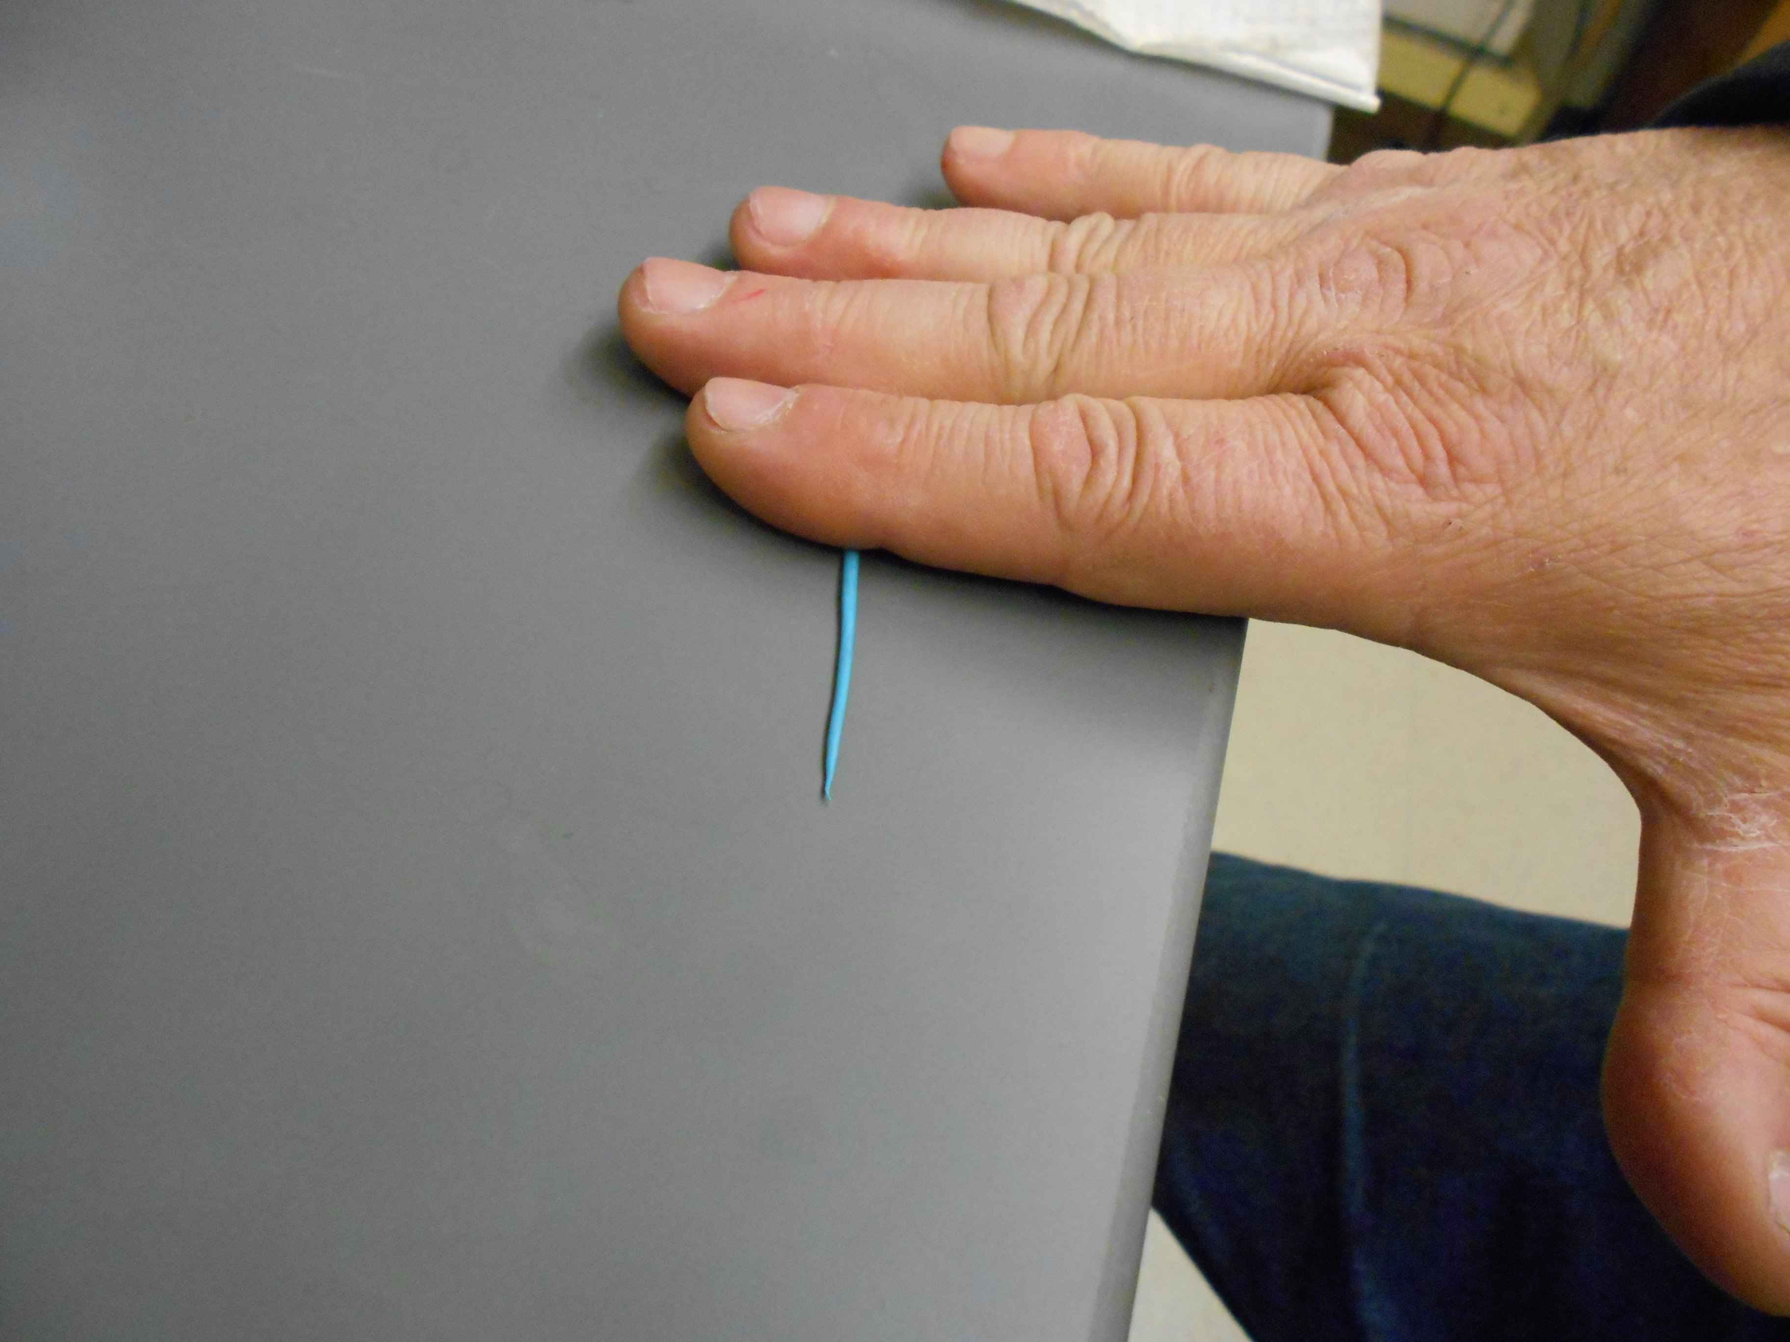Methods

1. Roll out a thin layer of Fun-Tak.
2. Place two pieces on a microscope slide

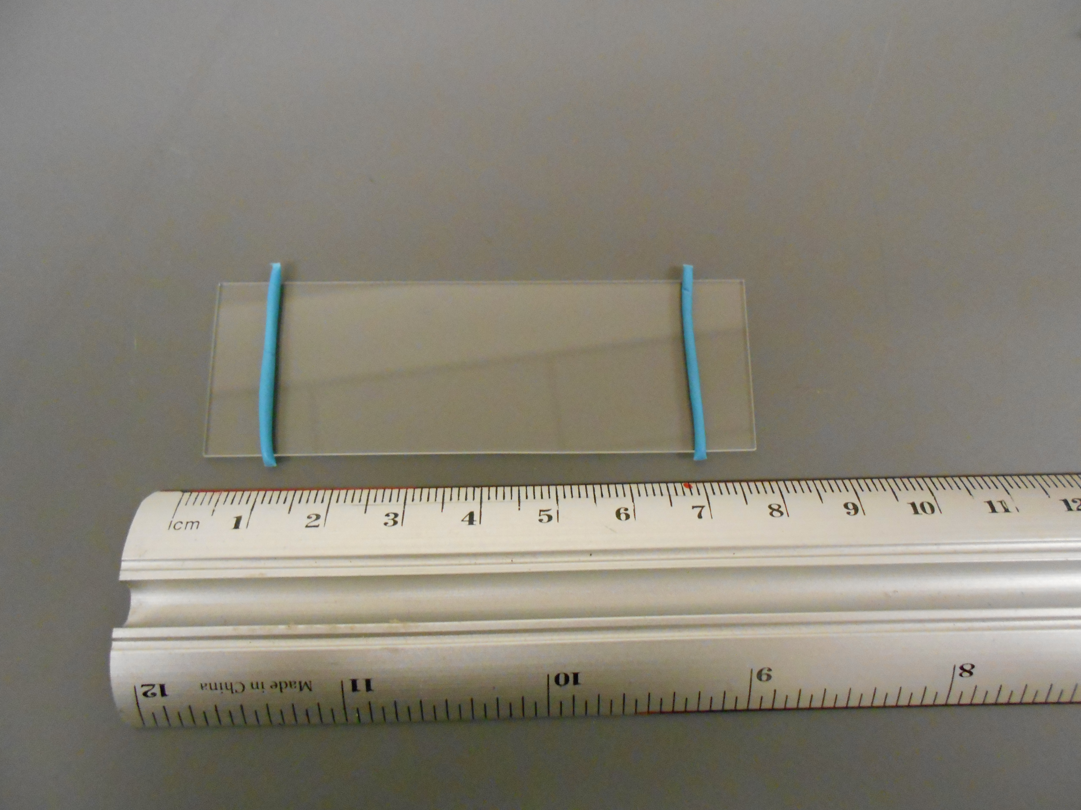

1. 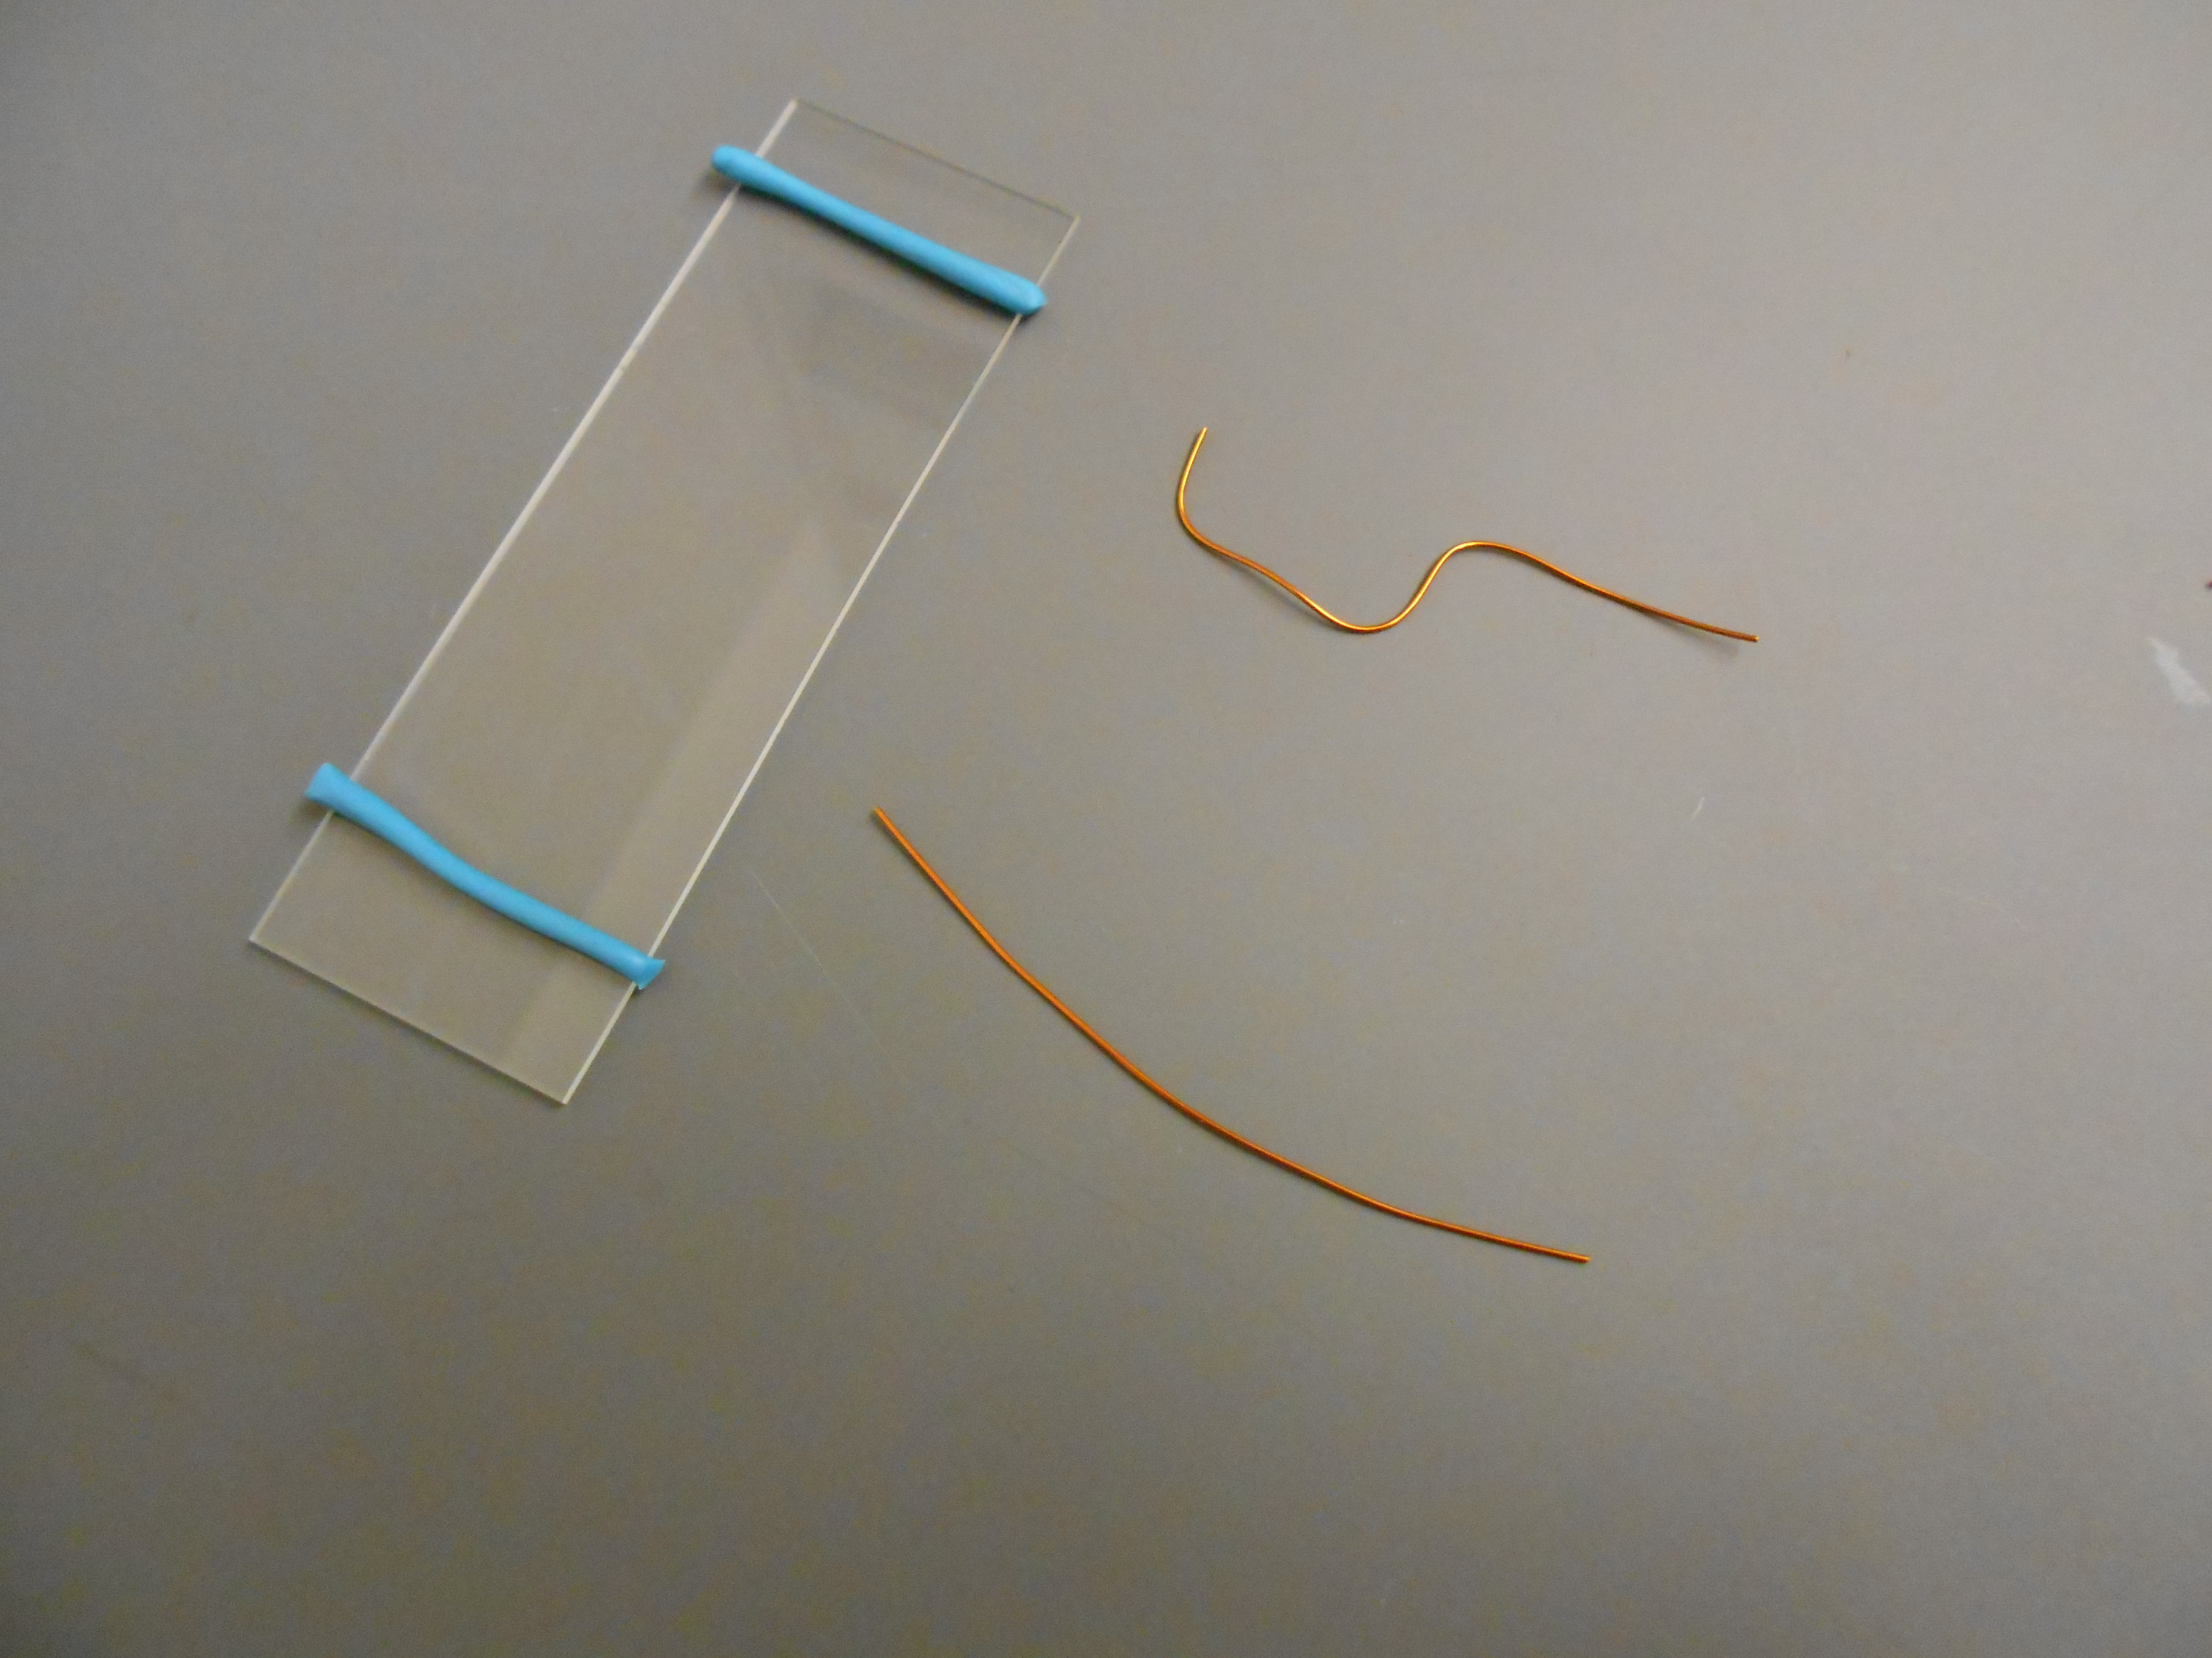Prepare two electrodes from the copper wire
2. Place them into the Fun-Tak strips

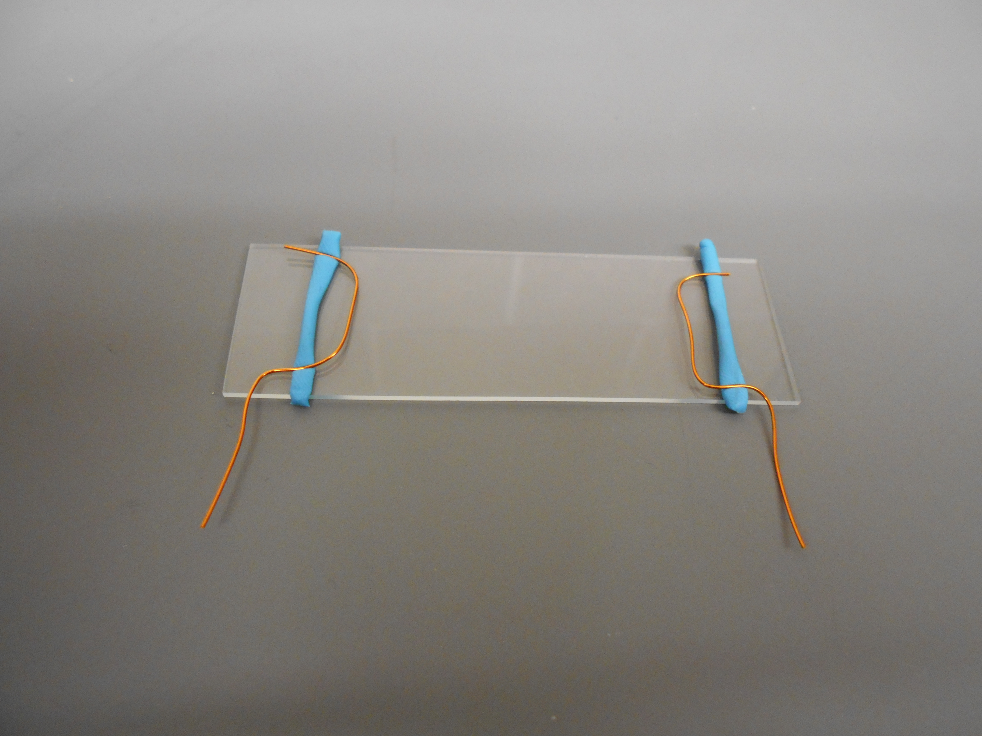

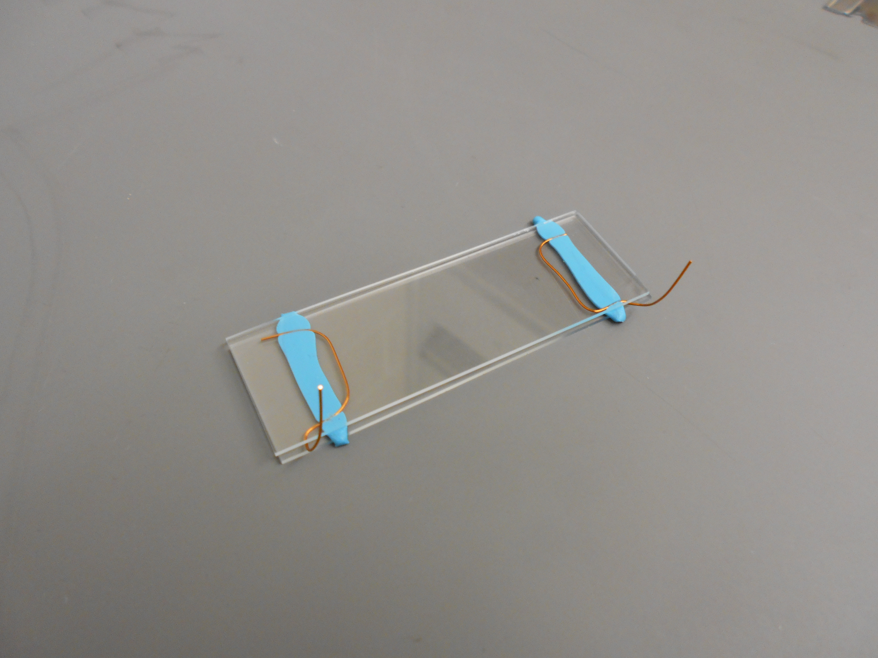

1. Place another slide on top and squeeze the slides together 🡪
2. 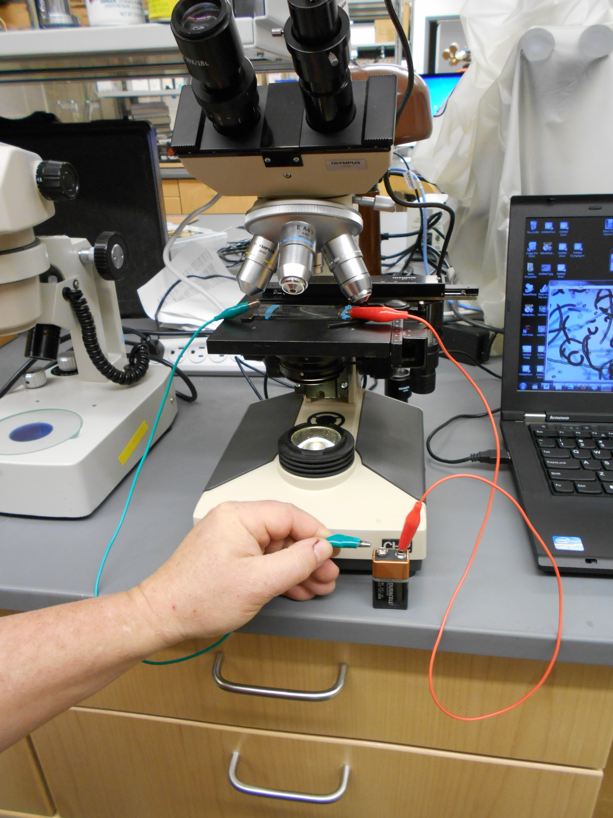Fill the chamber with Tetrahymena culture
3. Hook up a 9v battery with alligator clips.
4. Observe the process of galvanotaxis.

Experiments for Galvanotaxis

1. You can do the above experiment with starved cells (see previous experiments for how to starve cells)
2. Observe galvanotaxis in the presence of a Ca2+ channel inhibitor
3. By using different combinations of batteries, you can vary the voltage
4. Observe the phenomenon in the presence of a calcium ionophore, A23187 (100 μM final concentration)
5. Observe galvanotaxis in the presence of various concentrations of CaCl2

* Grow a 24 hour Tetrahymena culture in NEFF media
* Spin the cells in a clinical centrifuge for 1 minute at a setting of 4
* Pour off the supernatant and suspend cells in H20 (24μl)
* Repeat the above step
* Place 100 μl of the washed cells in a 1.5μl microcentrifuge tube
* Add various amounts (μl) of a 0.1 M CaCl2 stock solution
* Wait 30 minutes (includes chamber equilibration)
* Observe and document Tetrahymena behavior with and without the 9 volt battery

9.Aerotaxis in Tetrahymena

Tetrahymena show taxis to many different things. Aerotaxis is the movement of Tetrahymena toward oxygen. Aerotaxis is easy to demonstrate and use as an experimental system.

Materials

* Log culture of Tetrahymena
* Capillary tube
* Loctite Fun-Tak
* Microscope slide
* Dissecting microscope

Methods

1. Partially fill a capillary tube with Tetrahymena media but leave an air bubble at one end. Plug the ends without the air bubble with Fun-Tak.
2. Observe the accumulation of Tetrahymena at the air media interface.

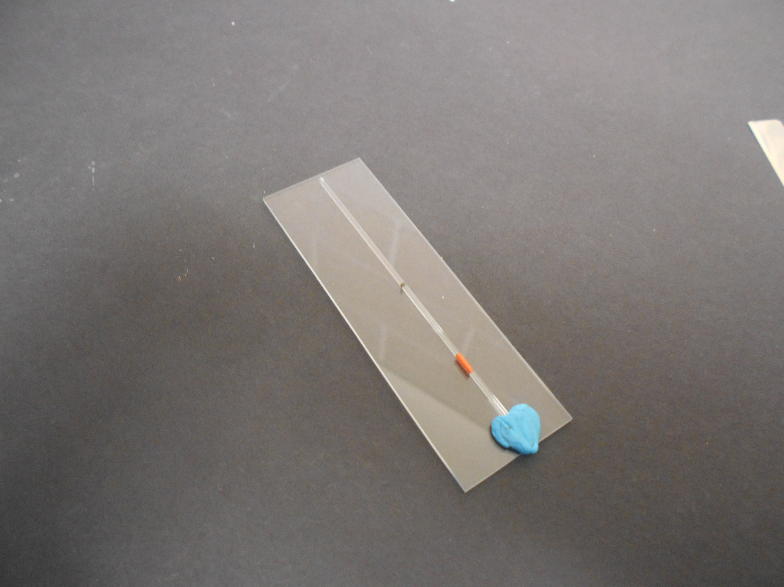

Experiments with Aerotaxis

1. You can observe the movement patterns of cells close to the O2 source and further away from the O2 source
   * Grow a 24 hour Tetrahymena culture in modified NEFF media
   * Load a slide chamber or capillary tube with Tetrahymena culture (For the capillary tube, be sure to leave one end **open**)
   * Wait and observe your chamber every 5 minutes; cells should accumulate at the end that is exposed to the air
     + Be sure to compare cell movement in the middle of the chamber or in the middle of the capillary tube to the O2 exposed region
   * Collect data (pictures, observations, movies, etc.)
2. You can investigate aerotaxis with starved cells or cells at the stationary phase of growth
   * Grow a Tetrahymena culture in modified NEFF media for 24 hours
     + To starve cells, wash them 2 times in 10μM TRIS-HCl pH 7.4 by spinning them in a clinical centrifuge at a setting of 4 for 1 minute
     + Suspend in 10μM TRIS-HCl pH 7.4 and wait 4-24 hours
     + For stationary cells, simply let your culture grow for 50-70 hours
3. You can test the effect of various pollutants on aerotaxis.
4. Test the effect of Ca2+ and K+ channel blockers on aerotaxis.

10.Tetrahymena Speed/Tumbling

One way to measure the health of Tetrahymena is to observe and measure their speed of forward movement or the amount of tumbling. Tetrahymena typically move with a burst of forward movement, but occasionally they tumble. They rarely tumble in the presence of an attractant but tumble more in the presence of a repellent.

Materials

* Hemocytometer
* Stop watch
* Tetrahymena culture

Methods

1. Place a 30 μl drop of culture onto the grid of the hemocytometer.
2. Measure the time it takes for a straight swimming Tetrahymena to cross two points of known distance.
3. You can also count the number of tumbles for a Tetrahymena over a given time period (remember that tumbling is an act of avoidance).
4. Be aware that the concentration of cells may have an effect, so use similar cell counts in your culture.

Experiments with Speed/Tumbling

1. Measure the speed and tumbling in the presence of attractants and repellents (see literature for ideas)
2. Measure the speed and tumbling with starved cells.
3. What effect do Ca2+ channel inhibitors have on speed and tumbling?
4. Is speed and tumbling pH dependent?

11.Acid Phosphatase Assay (Lysosomal enzymes)

Acid phosphatase is used as a marker enzyme for lysosomal cell fractions. Its presence in Tetrahymena growth media can also be an indication of lysosomal secretions. Lysosomes and lysosomal activity are closely related to phagocytosis.

Materials

* 1 M MgCl2
* 2% Triton x-100
* 0.5 KOH
* 0.05 M P-Nitrophenol (PNPP) (make fresh every 3 months)
* 1M sodium acetate buffer (pH 5.7)
  + Add 463.5 ml of 1 M sodium acetate to 36.5 ml of 1 M acetic acid
  + Add 1 M acetic acid, 20 ml glacial acetic acid to 340 ml H2O
* 5 ml glass pipette
* pipetters
* Test tubes
* Water bath
* Spectrophotometer

Assay

1. Add to test tube:
   1. 0.1 ml- 1 M sodium acetate buffer
   2. 0.1 ml- 0.1 M MgCl2
   3. 0.9 ml sample (cell prep, cell media, etc.)

*Make up a tube with 0.1 mg 1 M sodium acetate, 0.1 ml 0.1 M MgCl2, and 0.9 ml H2O as a blank to zero the spectrophotometer.

1. Start the reaction by adding 0.1 ml PNPP to the tubes
2. Place at 30O C for 15 minutes
3. Stop the reaction by adding 4 ml of 0.5 M KOH
4. READ at 405 mm after zeroing the spec with the blank tube.

*For assay with whole cells, add 16 μl of 2% triton x-100 to the reaction mix (it disrupts the cell membrane)

This assay can be used as a qualitative assay for acid phosphotase activity per cell or sample.

Acid Phosphotase Experiments with Tetrahymena

1. You can assay the amount of acid phosphotase secretion in the growth media under various conditions.

* Food source
* Temperature
* pH
* etc.

1. You can also measure the amount of secretion in the growth media by starved cells. You could also place starved cells in new media and assay the changes over time.
2. You could compare external amounts of acid phosphotase to internal (cell) amounts under various conditions
3. You could see if adding ink, carmine, yeast, or polybeads increases external or internal concentration of acid phosphotase.
4. You could examine if other protozoa excrete acid phosphatase
5. You could measure the effect of cytoskeleton inhibitors on lysosomal secretion

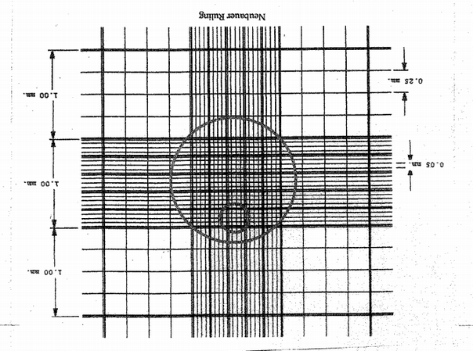Appendix

A. Hemocytometer Grid

B. Tetrahymena Growth Curve

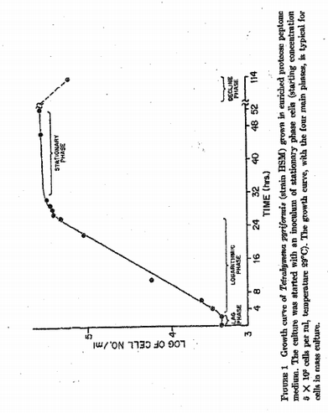

C. Defined Media

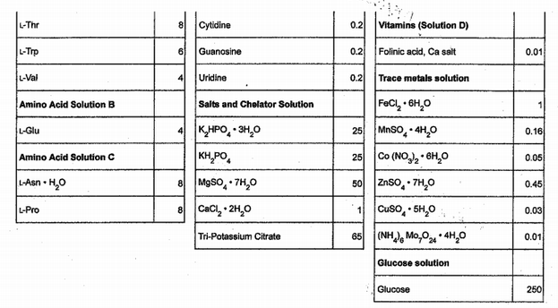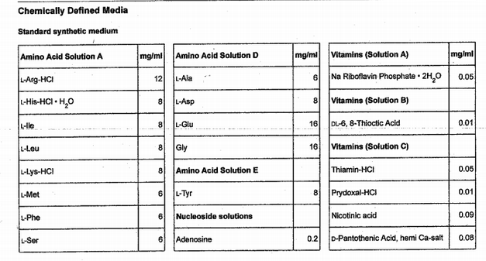

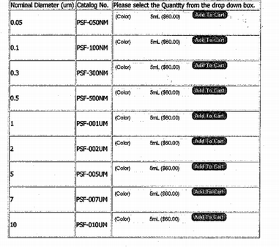D. Polybeads

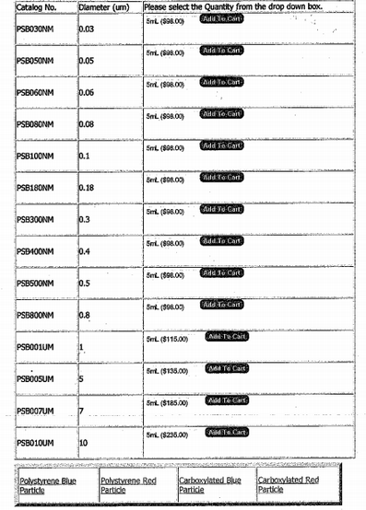

References

Bozzone, M. & Martin D. (2000). An Experimental system to study phagocytosis. In S. J. Karcher Editor (Eds.), Proceedings of the 21st Workshop/Conference of the Association for Biology Laboratory Education (406-4414).

Bozzone, M. (2005). Using microbial eukaryotes for laboratory instruction and student inquiry. M. A. O’Donnell Editor. Proceedings of the 26th Workshop/Conference of the Association for Biology Laboratory Education. (81-106).

Desjardins, M. & Griffiths, G. (2003). Phagocytosis: latex leads the way. *Current Opinion in Cell Biology*, *15*, 498-503.

Gerhardt, A., Ud-Daula, A., & Schramm, KW. (2010). *Tetrahymena spp* (Protista, Ciliophora) as Test Species in Rapid Multi-Level Ecotoxicity Tests. *Acta Protozoologica*, *49*, 271-280.

Gray, R., Gray, A., Fite, J., Jordan, R., Stark, S., & Naylor, K. (2011). A simple microscopy assay to teach the processes of phagocytosis and exocytosis. *Life Sciences Education, 11,* 180-186.

Gronlien, H., Berg, T., & Lovlie, A. (2002). In the polymorphic ciliate *Tetrahymena vorax*, the non-selective phagocytosis seen in microstomes changes to a highly selective process in macrostomes. *Journal of Experimental Biology, 205*, 2089-2097.

Hoffman, E., Rasmussen, L., & Zeuthen, E. (1974). Cytochalasin b: aspects of phagocytosis in nutrient uptake in *Tetrahymena*. *Journal of Cell Science*, *15,* 403-406.

Kim, D., Casale, D., Kohidai, L., & Kim, M. (2009). Galvanotactic and phototactic control of *Tetrahymena pyriformis* as a microfluidic workhorse. *Applied Physics Letters, 94,* 94-96.

Kim, D., Kim, P., Lee K., Kim, J. & Kim, M. (2013). The galvanotactic behavior of *Tetrahymena* *pyriformis* under electric fields. *Journal of Micromechanical and Microengineering, 23.*

Muller, M. (1972). Secretion of acid hydrolases and its intracellular source in *Tetrahymena pyriformis*. *The Journal of Cell Biology, 52,* 478-487.

Organ, A., Bovee, E., & Jahn, T. (1972). The mechanism of the water expulsion vesicle of the ciliate *Tetrahymena pyroformis*. *The Journal of Cell Biology*, *55,* 644-652.

Rothstein, T. & Blum, J. (1973). Lysosomal physiology in *Tetrahymena*: effect of glucose, acetate, pyruvate, and carmine on intracellular content and extracellular release of three acid hydrolases. *The Journal of Cell Biology*, *57,* 630-641.

Stoner, L. & Dunham, P. (1970). Regulation of cellular osmolarity and volume in *Tetrahymena*. *The Journal of Experimental Biology, 53,* 391-399.

Thompson, G., Baugh, L., & Walker, L. (1974). Nonlethal deciliation of *Tetrahymena* by a local anesthetic and its utility as a tool for studying cilia regeneration. *The Journal of Cell Biology*, *61,* 253-257.